**Topics: Descriptive Statistics and Probability**

1. Look at the data given below. Plot the data, find the outliers and find out $μ, σ, σ^{2}$

|  |  |
| --- | --- |
| **Name of company** | **Measure X** |
| Allied Signal | 24.23% |
| Bankers Trust | 25.53% |
| General Mills | 25.41% |
| ITT Industries | 24.14% |
| J.P.Morgan& Co. | 29.62% |
| Lehman Brothers | 28.25% |
| Marriott | 25.81% |
| MCI | 24.39% |
| Merrill Lynch | 40.26% |
| Microsoft | 32.95% |
| Morgan Stanley | 91.36% |
| Sun Microsystems | 25.99% |
| Travelers | 39.42% |
| US Airways | 26.71% |
| Warner-Lambert | 35.00% |

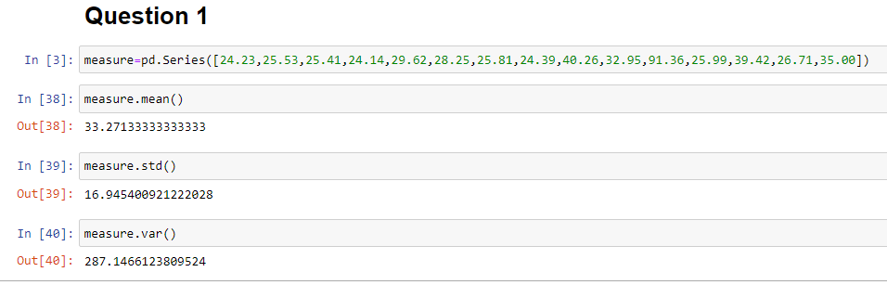

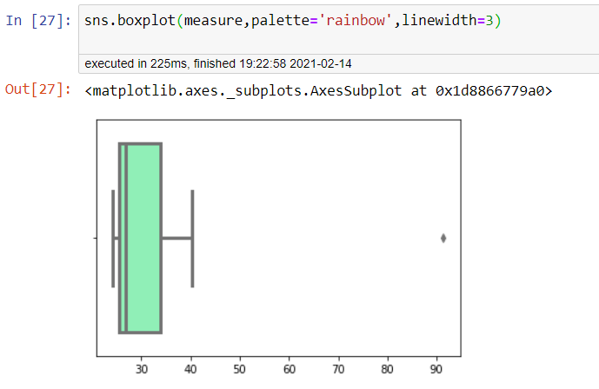

OUTLIER IS = 91.36

2.



1. Answer the following three questions based on the box-plot above.
2. What is inter-quartile range of this dataset? (please approximate the numbers) In one line, explain what this value implies.

* IQR=12-5=7, The **IQR** describes the middle 50% of data values when ordered from lowest to highest

1. What can we say about the skewness of this dataset?

* From the above boxplot we can say that it is slightly positively skewed because the length of the right side tail is longer when compared to the left side tail.

1. If it was found that the data point with the value 25 is actually 2.5, how would the new box-plot be affected?

* In that case we would not have the outlier and our new box plot will have more positive skewness



1. Answer the following three questions based on the histogram above.
2. Where would the mode of this dataset lie?

* Since it is a bimodal distribution we have modes i.e 5 and 7

1. Comment on the skewness of the dataset.

* Slightly positively skewed

1. Suppose that the above histogram and the box-plot in question 2 are plotted for the same dataset. Explain how these graphs complement each other in providing information about any dataset.

* Box plot explains that there exists an outlier clearly whereas histogram cannot explain the outlier clearly

1. AT&T was running commercials in 1990 aimed at luring back customers who had switched to one of the other long-distance phone service providers. One such commercial shows a businessman trying to reach Phoenix and mistakenly getting Fiji, where a half-naked native on a beach responds incomprehensibly in Polynesian. When asked about this advertisement, AT&T admitted that the portrayed incident did not actually take place but added that this was an enactment of something that “could happen.” Suppose that one in 200 long-distance telephone calls is misdirected. What is the probability that at least one in five attempted telephone calls reaches the wrong number? (Assume independence of attempts.)

Ans: => Probability of call misdirecting  p = 1/200

=> Probability of call not Misdirecting = 1 - 1/200 = 199/200

Number of Calls = 5

P(x) = ⁿCₓpˣqⁿ⁻ˣ

n = 5

p = 1/200

q = 199/200

at least one in five attempted telephone calls reaches the wrong number

= 1  -  none of the call reaches the wrong number

= 1  - P(0)

= 1   -  ⁵C₀(1/200)⁰(199/200)⁵⁻⁰

= 1  -  (199/200)⁵

= 0.02475

**probability that at least one in five attempted telephone calls reaches the wrong number = 0.02475**

1. Returns on a certain business venture, to the nearest $1,000, are known to follow the following probability distribution

|  |  |
| --- | --- |
| x | P(x) |
| -2,000 | 0.1 |
| -1,000 | 0.1 |
| 0 | 0.2 |
| 1000 | 0.2 |
| 2000 | 0.3 |
| 3000 | 0.1 |

1. What is the most likely monetary outcome of the business venture?

Ans: 2000

1. Is the venture likely to be successful? Explain

We can say that from the data the Probability of getting successful return is more than Losing the return(1100-300)=800

1. What is the long-term average earning of business ventures of this kind? Explain

800$ is the long term avg

1. What is the good measure of the risk involved in a venture of this kind? Compute this measure

Risk stems from the possible variability in the expected returns. Therefore a good measure to evaluate the risk for a venture of this kind would be variance or standard deviation of the variable x.

Here,

sd= 1870 and var=3500000

The large value of standard deviation of $1870 is considered along with the average returns of $800 indicates that this venture is highly risky.